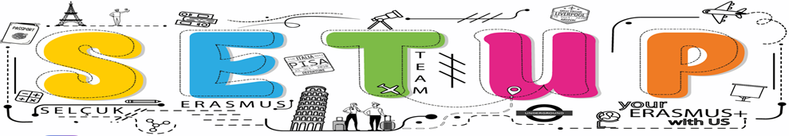

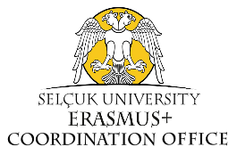
PARTNERSHIP FORM FOR ERASMUS+
(Blended Intensive Programme (BIP))

Please take a moment to read the document and information requested. If you need support or have any questions, please contact e-mail: erasmus@selcuk.edu.tr

INSTITUTIONAL INFORMATION
Institution | Selçuk University
Country | Turkey
PIC Number | 998993883
OID Number | E10206562
Web site | https://selcuk.edu.tr/
Social media (if available) | https://www.instagram.com/selcukuni.erasmus/
Number of students and staff | 69.000 students and 3,000 teaching staff
Course offer | https://selcuk.edu.tr/Birim/koordinatorluk/erasmus/2117/erasmus_dersler/49177
Contact person for Erasmus+ BIP Projects  (Full name, E-mail, Phone number) | Lec. Aysan Bilgin  aogul@selcuk.edu.tr  +903322234463
Please provide a short description of the profile of your institution. | Selçuk University, which started its educational activities in 1975, has high student / staff numbers and shopping center, swimming pool, tram, stadium etc. gathered in its enormous campus. It is one of the leading higher education institutions in Turkey with its many facilities. Selçuk University is a state university with a deep-rooted history, experience and institutional structure of nearly half a century. With its green, unhindered and student-friendly campus, it hosts students from 81 provinces of Turkey and abroad.
QUALITY QUESTIONS
- Relevance of the strategy
  - Explain why you want to foster Erasmus+ BIP.

The Erasmus+ exchange program is designed in a way to give the opportunity to students and staff to study, teach and do research at a university abroad at the outset. But now the exchange opportunity can enable them to improve their knowledge and skills, exchange experiences, and express their quality at the international level through using online facilities as well. Given the fact that that blended mobility including virtual mobility can also have an important role in capacity building with partner institutions for both staff/students’ part, and for more formal cooperation between partner universities. Thus, it broadens individual views through the international agenda, and strengthens intercultural competence of all parties involved.

  - Explain the preference given to a certain region/country. Is there any institutional policy favoring the cooperation with Türkiye? Is there any institutional policy favoring the cooperation with EU members & third countries associated to the Programme (Programme Countries) in specific?
Such blended mobility projects are highly needed given the increasing demand on hybrid facilities in higher education system on the one hand, but the limited financial resources provided to them around the world on the other hand. Our university encourages in-person education but also distance one, so supports the activities including blended programmes like this one.
  - Explain why the planned mobility project is relevant to the internationalization strategy of your institution.
Selcuk University considers “being a world-class research university” as its main goal in its Strategic Plan (2022-2026). According to our strategic goals, it is of great importance to increase international student/staff mobility and to develop international cooperation beyond Europe. Being a successful higher education institution is about both providing a good education/business life on campus and giving more opportunities to students and staff in international exchanges. Selcuk University, as a well-established university, has updated its goals in this direction. The 2022-2026 Strategic Plan of our university has been prepared by taking into account the high-level policy documents. As stated in Reference 563 of the Eleventh Development Plan, which is one of these documents, our country is aimed to increase the level of internationalization in the field of higher education.

  - Detail your previous experience of cooperation with higher education institutions in the EU or third countries associated to the Programme (Programme Countries), if any.
Explain how you expect that this project will contribute to new cooperation in education and/or research in the region.
As you can follow up from our web site and social media addresses, our university in general and our Erasmus Office specifically works in cooperation with many EU and Programme Countries in different aspects, such as Erasmus projects (KA131, 171, 202 etc.) or EU relevant / related projects/activities.
- Impact and Dissemination
  - Explain the impact and outcomes of the mobility project on the different stakeholders. What is the expected impact on the participants (e.g. what skills will they acquire)? What is the expected impact on your institution?
The BIP will contribute to the development of students and staff through both physical and virtual mobility. Students studying at a different university abroad will gain new experiences that they can share by increasing their knowledge and skills, improve their Eng through learning the technical terms in their field. Today, it is known that the rate of finding a job is higher for students with language skills. Moreover, mobility plays an important role in capacity building with partner institutions. Thus, the impact of the change process is not limited to individuals, but also includes institutions.
Staff mobility is considered in connection with the international recognition of our university and increasing the available opportunities abroad. So, both academic and administrative staff will make positive contributions to themselves and their institutions through new trainings. In addition, mobility will be a great opportunity to strengthen our international connections, establish new connections and make the most of these connections.

  - Explain the impact at local/regional/national level. How will the outcomes be measured and evaluated? How will you know whether you have achieved the desired and expected impacts?
Institutional level: Thanks to this cooperation that Selçuk University will establish with different countries, the strategic partnership document (2022-2026) will have achieved its goals. It will be an important step especially for internationalization goals. Specific meetings will also be held to identify other impacts on the institution.
Local-regional level: The project will have significant potential to diversify local and regional cooperation opportunities.
National level: The project will create new partnerships and cooperation in different types of EU projects.
Erasmus office plans to carry out many activities in the analysis and dissemination of project impacts. Many surveys will be conducted with the participants regarding the targeted effects. Evaluation of the survey answers will be effective in measuring the success of the project and the results will be shared on the university website. Meetings will be held to discuss the regional, institutional and national impacts of the project, and what needs to be done for students and staff to make the most of projects will be determined.

Thank you!

