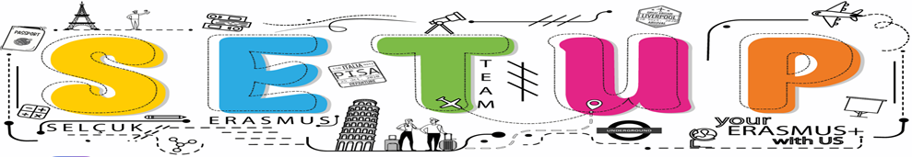
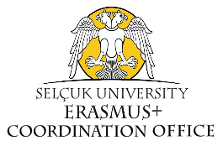
PARTNERSHIP FORM FOR ERASMUS+
If you need further support or have any questions, please contact e-mail: erasmus@selcuk.edu.tr
INSTITUTIONAL INFORMATION
Institution | SELÇUK UNIVERSITY
Country | TURKIYE
PIC Number | 998993883
OID Number | E10206562
Web site | https://selcuk.edu.tr/  https://selcuk.edu.tr/Birim/coordinatorships/erasmus/2117
Social media (if available) | https://www.instagram.com/selcukuniresmi/  https://www.instagram.com/selcukuni.erasmus/
Number of students and staff | 68370/3046
Course offer | https://selcuk.edu.tr/Birim/koordinatorluk/erasmus/2117/erasmus_dersler/49177#
Please provide a short description of the profile of your institution. | A world university with an Innovative, Sustainable, Modern and Green Campus
Primary contact person
Title: | Lec.
First name: | Zuhal
Family name: | Dursun
Position: | Vice Coordinator
Email: | erasmus@selcuk.edu.tr
Telephone: | +903322234461
Instituonal Coordinator
Title: | Assoc. Prof. Dr.
First name: | Zerrin
Family name: | Savasan
Position: | Institutional Coordinator
Email: | erasmus@selcuk.edu.tr
Telephone: | +90332234461
Legal representative
Title: | Prof. Dr.
First name: | Metin
Family name: | Aksoy
Email address: | meaksoy@selcuk.edu.tr
Position: | Rector
Telephone: | +903322238400

BACKGROUND AND EXPERIENCE
Please briefly present the partner organisation(e.g. its type, scope of work, areas of activity and if applicable, approximate number of paid/unpaid staff, learners and members of the group) | Selcuk University is a state university which is now among Turkiye’s largest educational institutions involving over 70.000 students.  It has a wide range of education opportunities ranging from health to social sciences and natural sciences with its 23 faculties, 6 graduate schools, 6 colleges, 22 vocational schools and a strong language education infrastructure with its Faculty of Literature and the School of Foreign Languages providing education in many languages.  More importantly, it has an enormous campus and many facilities ranging from a shopping-center, swimming pool, tram, stadium etc. With also its conservatory, sports academy, fine arts, graphic design, radio&Tv, technology faculties and Erasmus House, it frankly shows that it aims not only providing education opportunities for young people, but also encourage their social inclusion with different social facilities/activities.  And as a city university established in the center of Anatolian civilization, in a multicultural geography, it is also more than just a university. Reaching every individual who wishes with distance education activities, it is like a bridge between the city and the people with its Medical Faculty Hospital, Dental Clinics, Animal Hospital, Vocational Courses and Laboratories that are open to all people; and with its Barrier-Free Living Unit, Women-Family-Society, Autism and Elderly Care Research Centers working for people’s needs.
What are the activities and experience of the organisation in the areas relevant for Erasmus +? | Selcuk University has a deep-rooted history, experience and institutional structure of nearly half a century. In terms of the number of students, it ranks fifth with nearly 70,000 students and ninth among Turkish Universities with the number of teaching staff of 3.046.  It is obvious that our University offers an ideal environment for the conduct of partnerships and projects, related training and activities, especially with its recent successes. As a result of the research conducted at Stanford University in 2021, 8 scientists from our university were among the top 2% of the "World's Most Influential Scientists" list. As of 2022, the main campus of our university has become the 431st greenest campus in the world, according to the “UI GreenMetric World University Rankings 2022” data, which evaluates higher education institutions in the fields of sustainable, energy efficient, nature friendly and environmentally friendly. According to the 2022 Impact Rankings published by Times Higher Education (THE), it was among the top 4 universities in Turkiye in terms of quality education. As of 2023, Selçuk University has been among the top 15 universities in Turkiye for "scientific publications and citations", according to the "EduRank 2022" ranking, one of the world's leading university rating institutions. According to this evaluation, our university was ranked 3rd in machine learning, 7th in archeology and artificial intelligence, and 8th in environmental sciences and interior architecture.  In addition, as a result of the application made within the scope of the 1st term of 2022, “2209-A University Students Research Projects Support Program” carried out by the TÜBİTAK (THE SCIENTIFIC AND TECHNOLOGICAL RESEARCH COUNCIL OF TÜRKİYE) Scientist Support Programs Presidency, it was among the top 15 among 182 universities with 67 projects.
What are the skills and expertise of key staff/persons involved in Erasmus +? | Zerrin Savaşan is currently working as an Assoc. Prof. of Public International Law in SU. She is a member of the International Union for Conservation of Nature (IUCN) World Commission on Environmental Law (WCEL), founder of the Academy of Environmental Studies, Volunteer Youth Community; founding Member of the Environmental Peacebuilding Association (2018-2020); and Consultation Council Member of Turkish Bar Association, Commission on Environment and Urban. She is also MC Member of COST Action Programmes. She obtained her PhD degree from the Department of International Relations, Middle East Technical University (METU); Her postdoc research was conducted at the Institute for Transnational Legal Research (METRO), Law Faculty, Maastricht University. Her PhD research was conducted both at the Max Planck Comparative Public Law and International Law Institute, Heidelberg University, and in the Center for Environmental Studies, Vrijie University.  Lecturer/Expert Zuhal Dursun (Vice Coordinator) has been working in Erasmus Coordination Office for 8 years as responsible of organizing the students’ mobility processes efficiently and truly from the application processes until they completed their mobilities.  Lecturer/Expert Aysan Bilgin (Vice Coordinator) has been working in Outgoing Student Department at Erasmus Coordination Office for about three years.  İlyas Ferhat Demirbaş has PhD. Degree in Department of International Relations. He works as lecturer/expert with 15 years of experience in the Erasmus Office, SU. He has worked as an academic advisor of the European Union and Erasmus, ESN Selçuk Student Communities, and the founding president of the European Youth Community Association. He also took part in dozens of EU projects as an executive, expert, and trainer. He is also Member of WG’s of COST Action Programmes. As project co-coordinator, he will be particularly responsible for establishing and managing relationships with other partners.
Thank you!
